Wayne’s


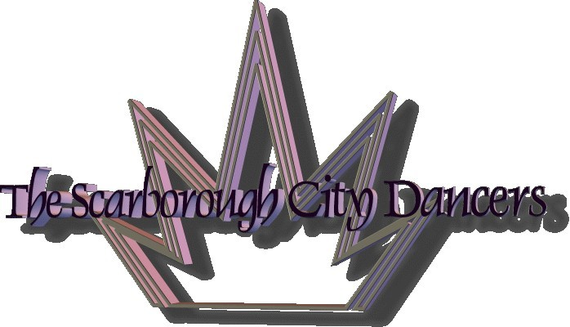

‘DANCE-N-TIME’ INSTRUCTION SCHEDULE

For the Scarborough City Dancers


Clogging, Line Dancing, Line Tap, and GOLD

April to June 2012
Week Day | Community  Centre | Class | Time of Day
Monday  * | Scarborough Village C. C. | Clogging – Basic/Beginner  - Intermediate | 10:40 am - 11:40 am  11:45 am -12:45 pm
Monday  * | Oakridge C. C.  (1st & 3rd Monday each month) |   Drop-In Line Dancing | 1:30 pm - 3:00 pm
Tuesday  * | Ellesmere C. C. | Line Dancing - Intermediate | 9:45 am - 10:45 am
Tuesday  * | Scarborough Village C. C. | Line Tap – Beg. +/Intermediate | 11:30 am -12:30 pm
Tuesday  * | Ellesmere C. C.  (2nd Tuesday of each month) | Drop-In Line Dancing | 2:30 pm - 4:00 pm
Wednesday | Scarborough Village C. C. | Line Dancing - Fun Level    RHYTHM 'N MOTION  GOLD | 10:45 am -12:15 pm
Wednesday |  |  | 12:20 pm - 1:20 pm
Wednesday | Stephen Leacock C. R. C. | Clogging – Low Intermediate | 2:00 pm - 3:00 pm
Wednesday | Scarborough Village C. C. | Clogging – Intermediate | 8:00 pm - 9:00 pm
Thursday | Birkdale C. C. | Line Dancing – Easy Fun Level  Line Tap - Intermediate | 9:00 am - 10:00 am  10:15 am - 11:15 am
Thursday | Ellesmere C. C. | GOLD | 1:15 pm - 2:15 pm
Thursday | Ellesmere C. C. | Line Dancing – Beginner | 2:15 pm - 3:15 pm
Friday | Stephen Leacock C. R. C. | Line Tap - Intermediate | 9:30 am - 10:30 am
 | L’Amoreaux C. R. C. | GOLD | 11:15 am - 12:15 pm
 | Birkdale C. C. | GOLD | 1:15 pm - 2:15 pm
 | Stephen Leacock C. R. C. | GOLD | 3:00 pm - 4:00 pm

